Bayer Norway AS Transparency Statement Norway 2024
In accordance with the Norwegian Transparency Act

Introduction
This statement outlines Bayer’s due diligence activities in 2024 to identify, prevent, and mitigate actual and potential adverse impacts on fundamental human rights and decent working conditions. It is published in accordance with the Norwegian Transparency Act (2022), which requires large enterprises to carry out and publicly account for human rights due diligence. This statement describes and sets out the steps taken by Bayer AG and its affiliates (“Bayer”), herby Bayer Norway AS.
We (the "Bayer Group", "Group", "Bayer" or "the company") stand for respecting human rights in everything we do and will not turn a blind eye to any violation of human rights. We recognize the increase of modern slavery violations worldwide and acknowledge our responsibility to conduct human rights due diligence to prevent, mitigate and remedy risks and violations. We are committed to respecting and fostering human rights within our own business activities and in business relations and to reporting transparently on the results of our activities in this area.
This Statement builds upon our earlier Modern Slavery Act Statements and summarizes our activities to combat modern slavery and human trafficking in 2024.
The term 'human rights', as used in this Statement, includes modern slavery, human trafficking, forced and child labour.
Bayer is a founding member of the UN Global Compact (UNGC) and respects the Universal Declaration of Human Rights and the International Covenants on Civil and Political Rights and on Economic, Social and Cultural Rights of the United Nations. Our human rights due diligence is based on the human rights due diligence principles described in the UN Guiding Principles on Business and Human Rights (UNGPs) and the OECD Guidelines for Multinational Enterprises.
We are committed to respecting these principles along the entire value chain and within our scope of influence worldwide. We also support the Tripartite Declaration of Principles concerning Multinational Enterprises and Social Policy of the International Labour Organization (ILO), and the latter's core labour standards.
Our commitment to act responsibly along the entire value chain forms a core element of our sustainability strategy and encompasses our commitment to respect human rights. We acknowledge that the implementation of human rights due diligence is a continuous process that must be constantly adapted and improved.
With our Human Rights Policy, we define the human rights requirements within the company. This binding policy enables us to respect and foster human rights within our own business activities and in business relations. This policy applies to all Bayer employees worldwide and considers the engagement along the entire value chain, including our suppliers, business partners, customers, consumers, and local communities alike.
In addition to identifying, assessing, and addressing potential and actual human rights risks and violations, we also strive to contribute positively towards human rights. We have defined clear sustainability goals that make an important contribution to promoting self-determined living, exerting a positive influence on human rights. This is achieved not only by reducing our ecological footprint, but also by reaching many people in underserved regions with broader access to health care and nutrition.

Company Overview
Bayer Norway AS is a part of the Bayer Group of companies (Bayer), a life science company and a global leader in healthcare and nutrition. The Bayer Group has its head quarter in Germany. Our innovative products support efforts to overcome the major challenges presented by a growing and aging global population. We help prevent, alleviate, and treat diseases, empower people to take better care of their own health needs, and play a part in ensuring that enough agricultural products are produced while respecting our planet's natural resources. Our activities are guided by our mission: "Health for all, Hunger for none." Bayer AS operates in the three divisions Pharmaceuticals, Consumer Health and Crop Science.
Our operations
As the parent company of the Bayer Group, Bayer AG performs the principal management functions for the entire enterprise. This includes strategic alignment, resource allocation, financial affairs, managerial staff, and operations across our divisions:
- Crop Science: Leading in agriculture with crop protection, seeds, and traits.
- Pharmaceuticals: Focused on prescription products, especially in cardiology, oncology, hematology, ophthalmology, and radiology.
- Consumer Health: A top supplier of nonprescription (OTC) medicines.
- Enabling Functions: Includes Public Affairs, Sustainability & Safety (PASS), Group Finance, HR, IT, and Leaps by Bayer (disruptive innovation).
Workforce Overview and Employment Practices
Bayer employed 94,081 people globally at the end of 2024, down from 101,139 in 2023. The workforce distribution was:
- 45% in Europe, Middle East, and Africa
- 20.8% in Asia-Pacific
- 20.8% in North America
- 13.8% in Latin America
Only 2.4% of employees were on temporary contracts. Bayer emphasizes fair treatment, diversity, and inclusion, guided by its Code of Conduct and Human Rights Policy. Key employment principles include:
- Fair and equitable treatment: Protection from discrimination, harassment, and retaliation.
- Fair compensation: A globally consistent system combining base pay, performance incentives, and benefits.
- Living wages: All employees, including part-time and temporary staff, are paid above statutory minimums, aligned with benchmarks for Business for Social Responsibility (BSR).
- Equal pay: Commitment to gender pay equity for similar roles and experience levels.
In Bayer Norway AS we had in 2024 8 employees. Our sister company Bayer AS had in 2024 124 employees representing 12 nationalities. 4 employees (3,22%) were on temporary contracts.
Supply Chain Scope and Risk Awareness
Bayer’s supply chain is vast and global, comprising 87,893 suppliers in 2024 (up from 85,895 in 2023). The company sources:
- Direct materials: Active ingredients, raw materials, intermediates, finished products, and seeds.
- Indirect materials and services: For R&D, marketing, distribution, administration, and technical operations.
Bayer emphasizes local procurement, with 77% of procurement spend occurring locally in 2024. This approach supports local economies and enhances responsiveness to site-specific needs.
The company also tracks the geographical distribution of suppliers and procurement spend, noting that 8% of its purchasing volume comes from countries with a high risk of modern slavery. This insight informs Bayer’s risk management and due diligence strategies, which are detailed in later sections of the statement.
Bayer AS (Norway) supplier statistics:
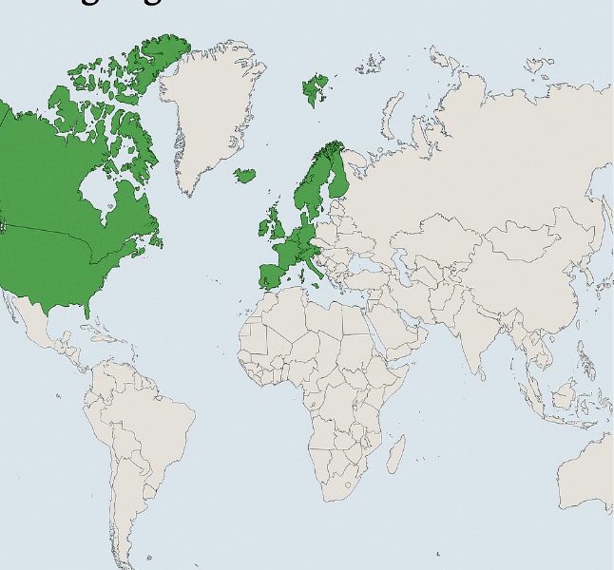
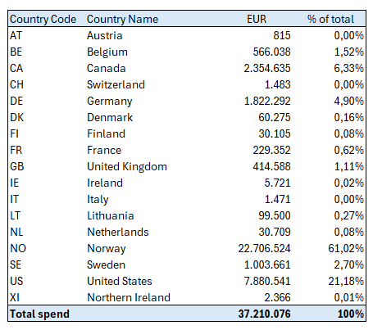
With regards to modern slavery, our analysis shows that our purchasing volume comes from countries with very low risk profile in 2024.
Due Diligence Framework
Bayer’s due diligence process is aligned with the OECD Guidelines for Multinational Enterprises and the UN Guiding Principles on Business and Human Rights. Our approach includes:
- Embedding responsible business conduct in policies and procedures.
- Identifying and assessing actual and potential adverse impacts.
- Implementing measures to prevent, mitigate, or remedy such impacts.
- Tracking the effectiveness of these measures.
- Communicating transparently with stakeholders.
- Providing or cooperating in remediation where necessary.

Human Rights Governance
- Human rights oversight lies with the Chairman of the Board of Management (CEO).
- The Public Affairs, Sustainability & Safety (PASS) function and a dedicated Human Rights Officer support this work.
- An external Sustainability Council advises Bayer on sustainability and human rights.
- Governance is managed globally by Bayer AG and applies to all reporting entities

Human Rights Strategy
By 2030, Bayer wants to be industry-leading in our approach to human rights, based on our human rights strategy.
Bayer have signed a Modern Slavery Act Statement for the fiscal year 2024 (from January 1st to December 31st, 2024), in compliance with the requirements of the United Kingdom Modern Slavery Act (2015), the Australian Modern Slavery Act (2018) and the California Transparency in Supply Chains Act (2010). It sets out the steps taken by Bayer AG and its relevant affiliates (“Bayer”).
The Modern Slavery Act states that Bayer stand for respecting human rights in everything we do and will not turn a blind eye to any violation of human rights. We recognize the increase of modern slavery violations worldwide and acknowledge our responsibility to conduct human rights due diligence to prevent, mitigate and remedy risks and violations. We are committed to respecting and fostering human rights within our own business activities and in business relations and to reporting transparently on the results of our activities in this area. This Statement builds upon our earlier Modern Slavery Act Statements and summarizes our activities to combat modern slavery and human trafficking in 2024.

Human Rights Due Diligence in accordance with UNGPs and OECD at Bayer
We implement measures to respect human rights both within our own company and along our entire value chain. Group regulations and processes, as well as management and monitoring systems, regulate the implementation of human rights standards. We are aware that the implementation of human rights due diligence is a continuous process that must be constantly adapted and improved. To ensure respect for human rights in the value chain in a targeted manner, Bayer operates according to a due diligence approach that is based on the UNGPs and OECD Guidelines for Multinational Enterprises. Guided by our human rights strategy and Group -wide management systems, our due diligence process comprises a declaration of principles, risk identification and assessment processes, prevention and mitigation measures, the implementation of remedial measures, and measures for determining effectiveness and reporting, along with access to grievance mechanisms.

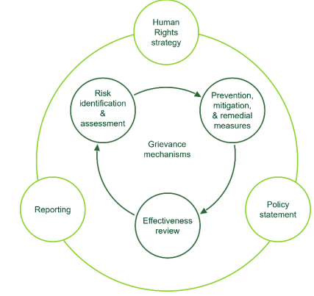

Our efforts and progress on strengthening our human rights due diligence efforts is reported in the Human Rights Chapter in our https://www.bayer.com/en/sustainability/sustainability-reports.

Risk identification and Assessment
We use a risk analysis to identify potentially detrimental effects of our business activities on human rights. In doing so, human risks are identified and prioritized, evaluated and prioritized from an overarching risk analysis for selected areas. Our risk analysis is aligned to the Chemie³ industry standard:
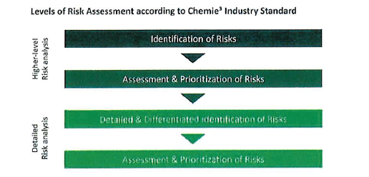

Bayer employs a structured, two-step risk analysis process to uncover potential human rights violations. This begins with identifying risks across its business activities and supply chains, followed by assessing these risks based on severity, likelihood, and materiality. The company distinguishes between gross risks (those existing without mitigation) and net risks (after mitigation measures are applied).
Through this process, Bayer has identified six key human rights priorities:

// Right to health
// Responsible use of natural resources
// Protection against child labor
// Right to freedom from slavery, servitude and forced labor
// Right to fair and favorable working conditions
// Right to freedom of association

These areas are considered both salient (most severely impacted) and material (important to stakeholders).
Bayer also conducts annual in-depth risk classifications of its suppliers, focusing on country and category-specific risks. In 2024, 157 strategic suppliers and 326 high-risk suppliers were evaluated, representing a significant portion of the company’s procurement spend.

Measures to address risks
To address these risks, Bayer has implemented a robust framework of policies and procedures. Central to this is the company’s globally binding Human Rights Policy and its Supplier Code of Conduct, which align with international standards such as the UN Global Compact and ILO conventions. These documents explicitly prohibit child labour, forced labour, and human trafficking. Our Group regulations, processes, management and monitoring systems regulate the implementation of human rights standards, within our own operations and the supply chain.

Our Group regulations – for own operations and supply chain
Bayer has documented its stance on human rights, including modern slavery, human trafficking and forced and child labour, in a globally binding Bayer Human Rights Policy, which defines the human rights requirements within the company and obligates us to respect and foster human rights within our own business activities and in business relations. Our commitment to respect human rights extends to all Bayer employees worldwide and the entire value chain, comprising business partners, suppliers, contractors, customers, consumers, and local communities.
In 2024, guided by our Code of Conduct and supplementary to our Human Rights Policy, we followed specific standards and responsibilities for respecting human rights in existing rules and Group regulations. These included the Legal, Compliance and Insurance Policy, along with regulations on Digital Policy, and HSE management & HSE key requirements.
Additionally, we have a Supplier Code of Conduct in place that specifies what we expect of our suppliers and obligates them to fully respect human rights, including the right to be free from slavery, servitude and forced labour as well as protection against child labour.
With respect to clinical trials, we strictly align ourselves to the Declaration of Helsinki, a set of ethical principles regarding medical research involving humans, adopted in 1964, and other international ethical norms and standards (e.g. from the Council for International Organizations of Medical Sciences (CIOMS) and the International Council for Harmonization of Technical Requirements for Pharmaceuticals for Human Use (ICH)). These principles are also specified in our Supplier Code of Conduct.
Employee Training and Awareness
Bayer has made employee training a cornerstone of its human rights strategy. In 2024, over 74% of employees received training on human rights topics, totaling more than 144,000 hours. These sessions covered:
- Fairness and respect in the workplace
- Health and safety protocols
- Data privacy
- How to identify and respond to human rights violations
A key component is the “Respecting Human Rights at Bayer” training course, available in nine languages. This course is mandatory for employees in high-risk roles and has received external recognition for its quality and learner engagement.
To further deepen understanding, Bayer hosted interactive learning sessions with internal and external human rights experts. These sessions focused on the global policy landscape and the importance of continuous improvement in human rights management.

Supplier Engagement and Risk Management
We have established a four-step process throughout the Group to improve sustainability practices in the supply chain. The sustainability landscape encompasses human rights topics including modern slavery, human trafficking and forced and child labor.
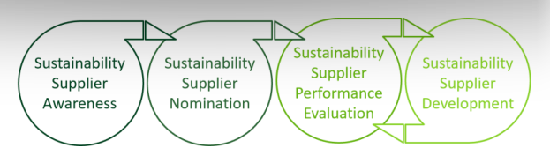

The four steps are:
- Supplier Awareness: Communicating expectations through the Supplier Code of Conduct and contractual clauses.
- Supplier Nomination: Selecting suppliers for evaluation based on risk classifications.
- Supplier Performance Evaluation: Conducting online assessments and on-site audits.
- Supplier Development: Supporting suppliers in improving their practices through re-evaluations and corrective actions.
More details can be found in our Impact report 2024

This process is managed by a dedicated sustainability unit within procurement and is implemented in collaboration with the Public Affairs, Sustainability & Safety (PASS) function.
The Supplier Code of Conduct is available in 21 languages and includes detailed expectations on ethics, labour rights, environmental protection, and governance. It is regularly updated to reflect evolving legal requirements and best practices.

Supplier Training and Industry Collaboration
Bayer also provides training and guidance to suppliers, including a supplementary document that offers practical examples for addressing modern slavery risks. The company collaborates with two major industry initiatives:
- Pharmaceutical Supply Chain Initiative (PSCI): Delivered over 50 training sessions and hosted global conferences in 2024, reaching more than 1,100 supplier representatives.
- Together for Sustainability (TfS): Offers practical training through the TfS Academy. In 2024, Bayer selected around 160 suppliers for participation based on performance and risk assessments.

Tracking and Reviewing Effectiveness of Measures
Bayer has developed a robust framework to track the implementation and effectiveness of its human rights initiatives. This includes both internal and external mechanisms:
Internal Audits: Conducted by Bayer’s Internal Audit department, these audits are risk-based and follow international standards (e.g., Institute of Internal Auditors). They assess:
  - Compliance with labour laws and hiring practices (including age verification)
  - Working hours and wage standards
  - Procurement processes, including contractor management
In 2024, Bayer conducted 73 audit reports, including 8 compliance-related investigations.
Supply Chain Monitoring: Bayer uses a combination of EcoVadis online assessments and on-site audits to evaluate supplier performance. These assessments cover:
  - Labour and human rights
  - Environmental practices
  - Ethical conduct
  - Sustainable procurement
In 2024:
  - 1,324 suppliers were assessed via EcoVadis
  - 131 suppliers were audited either by Bayer or third-party auditors
These evaluations are tailored to the supplier’s size, location, and industry, ensuring a risk-based and context-sensitive approach.
Supplier Development and Remediation
Bayer’s approach to supplier improvement is collaborative and corrective, rather than punitive. The company operates a Supplier Development Program that supports suppliers in addressing identified shortcomings:
- In 2024, 122 suppliers were added to the development program.
- 34 suppliers completed the program successfully, with a 97% improvement rate.
- 12 suppliers were flagged for critical issues (e.g., wage violations, unsafe working conditions), triggering corrective action plans and follow-up audits.
Bayer emphasizes long-term engagement with suppliers to improve labour practices and human rights protections. The company reserves the right to terminate relationships if no improvement is observed, but in 2024, no supplier relationships ended solely due to sustainability performance.
Overall, 858 suppliers improved their sustainability performance in 2024, up from 687 in 2023, reflecting Bayer’s commitment to continuous improvement.

Grievance mechanisms
Bayer maintains a comprehensive grievance mechanism to ensure that employees, suppliers, and external stakeholders can report concerns safely and confidentially:
- The “Speak Up” campaign is a global initiative that promotes a culture of openness and integrity.
- Reports can be submitted via:
  - Web portal
  - Mobile app
  - Email (Speak.up@bayer.com)
  - Phone (in the caller’s preferred language)
- Reports can be made anonymously, where legally permitted.
All reports are processed through a standardized investigation system. If a violation is confirmed, Bayer applies a graduated set of disciplinary measures, ranging from warnings to termination and legal action.
In 2024:
- 570 reports were received, including 411 anonymous submissions
- No confirmed cases of child labour, forced labour, or human trafficking were found
To enhance transparency, Bayer published an infographic explaining how complaints are handled and reaffirmed that its grievance mechanisms can address all forms of modern slavery.
In addition to the global channels Bayer AS maintains an open communication channels for stakeholders, including employees, customers, and suppliers, to report concerns or violations. Reports can be submitted via the company’s contact form or whistleblower channels.

Transparency and Public Access
This statement is publicly available on Bayer’s website and fulfills the requirement to account for due diligence under Section 5 of the Transparency Act. It includes:
- A description of Bayer’s structure and policies.
- Identified risks and actual adverse impacts.
- Measures taken and their effectiveness.
Bayer also responds to written requests for information under Section 6 of the Act and provides responses within three weeks or two months if the request is extensive.

Reporting
We regularly inform the public about our strategy, approaches and results in connection with human rights due diligence. One example is this annually published Sustainability Report. https://www.bayer.com/en/sustainability/sustainability-reports

The full Bayer Modern Slavery Act Statement 2024:
Bayer Modern Slavery Act Statement 2024
The full Bayer Sustainability Report 2024:
Bayer Sustainability Report 2023

Future Commitments
Bayer is committed to continuous improvement. In 2024, we:
- Updated our Human Rights Policy.
- Strengthened our internal Human Rights Community.
- Enhanced supplier development and grievance mechanisms.
We will continue to refine our due diligence processes and stakeholder engagement in line with evolving legal and ethical standards.

Contact Information
For inquiries related to this report or Bayer AS’s due diligence practices, please contact:
Bayer Norway AS –
Contact Form

